**Circuit Diagram & Truth Table:**

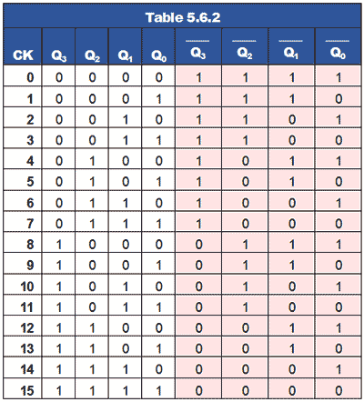

**Code:**

* **Design Module**

module counter(q,clk,clr);

input clk,clr;

output [3:0]q;

reg [3:0]q;

always @(negedge clk or posedge clr)

begin

if(clr)

q=4'b0000;

else

q=q+1;

end

endmodule

* **TestBench**

module Baig;

reg clr,clk;

wire [3:0]q;

counter c1(q,clk,clr);

initial

clk=1'b0;

always #5

clk=~clk;

initial

begin

clr=1'b1;

#10

clr=1'b0;

end

initial

#250

$finish;

endmodule

**Output:**

